Name:_chittetiSaikiran ps.n0:-10694004

1 ) Push STS code to git

Individual Backend code GITHUB URL : <https://github.com/chittetisaikiran/assignment-4.git>

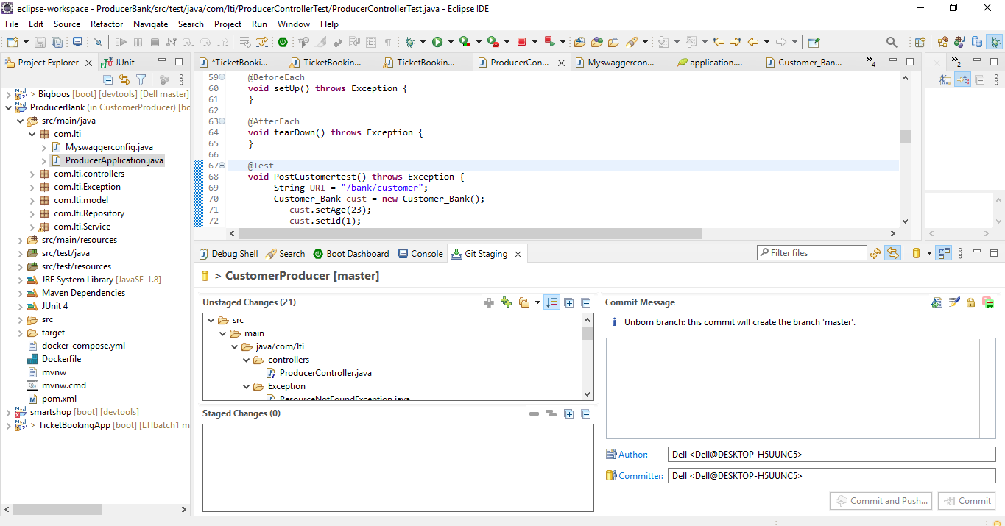

(ii)

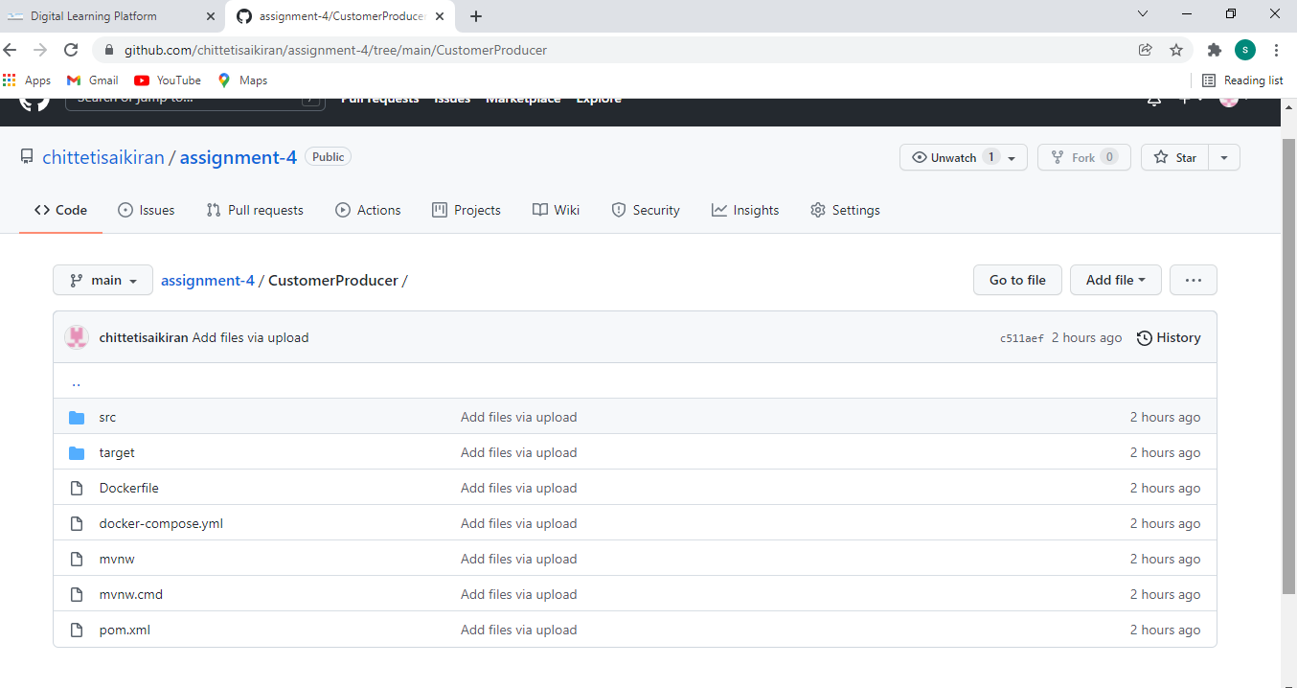

3. Junit Test Cases5

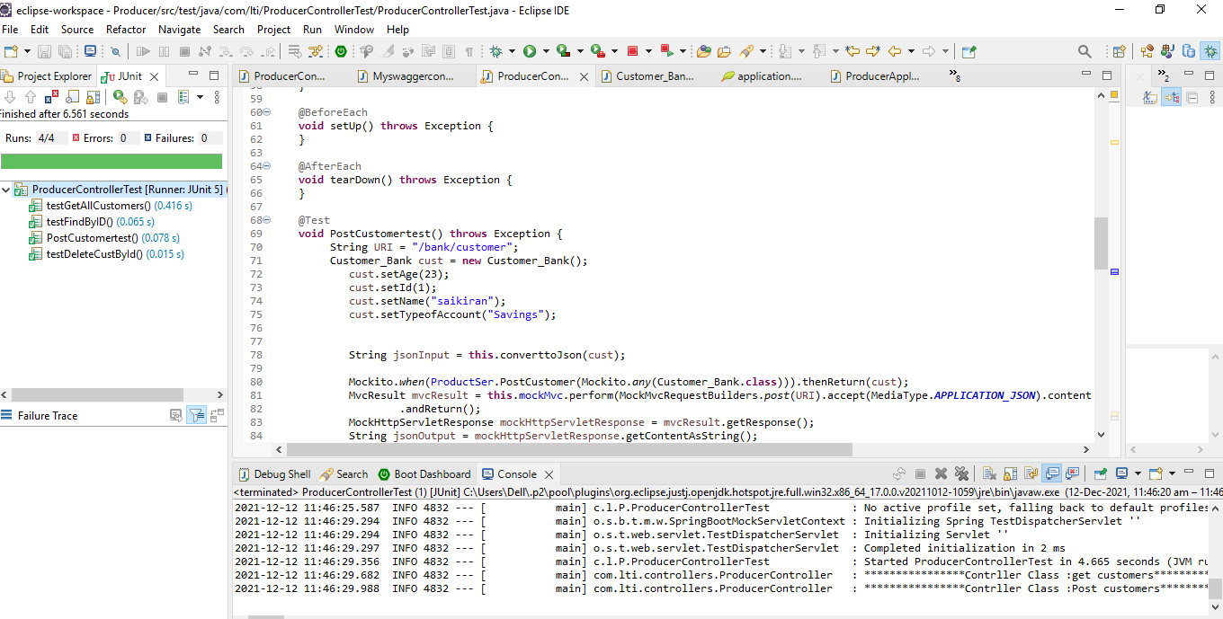

5. Logger implementation 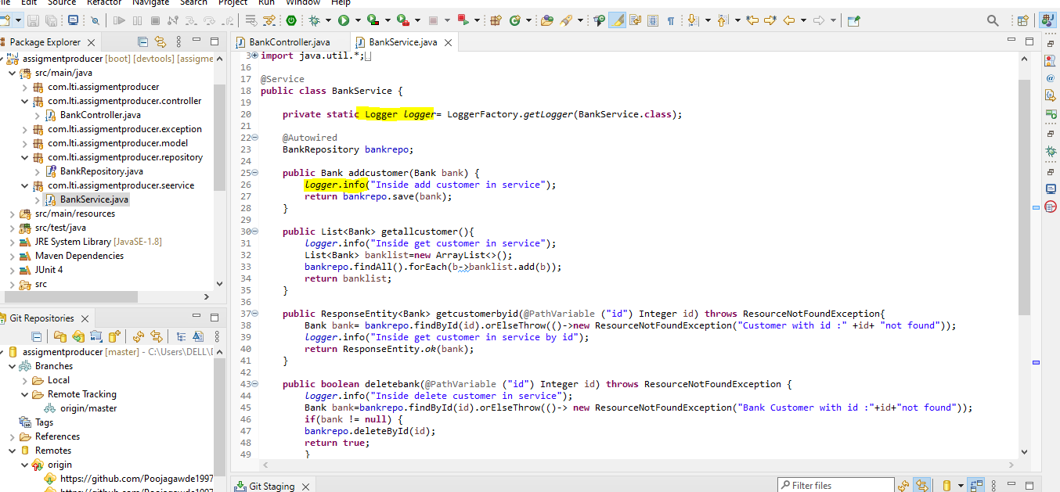

6.Debugging

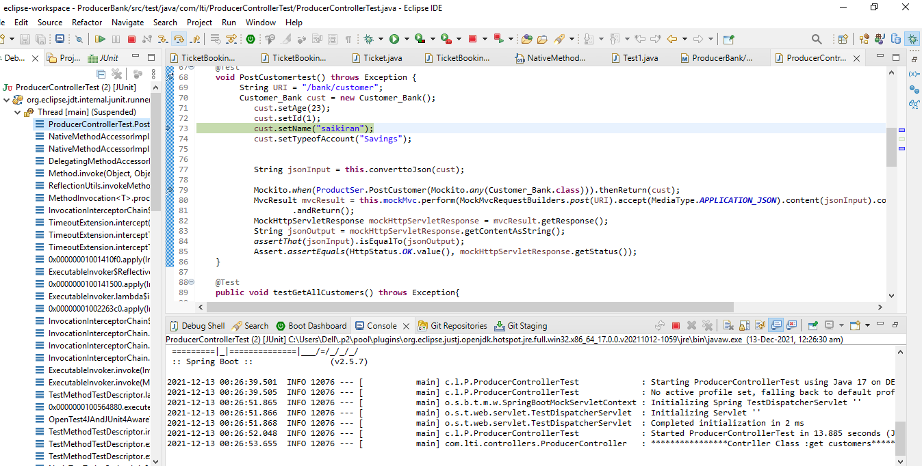

7 ) Code quality using Sonarlint

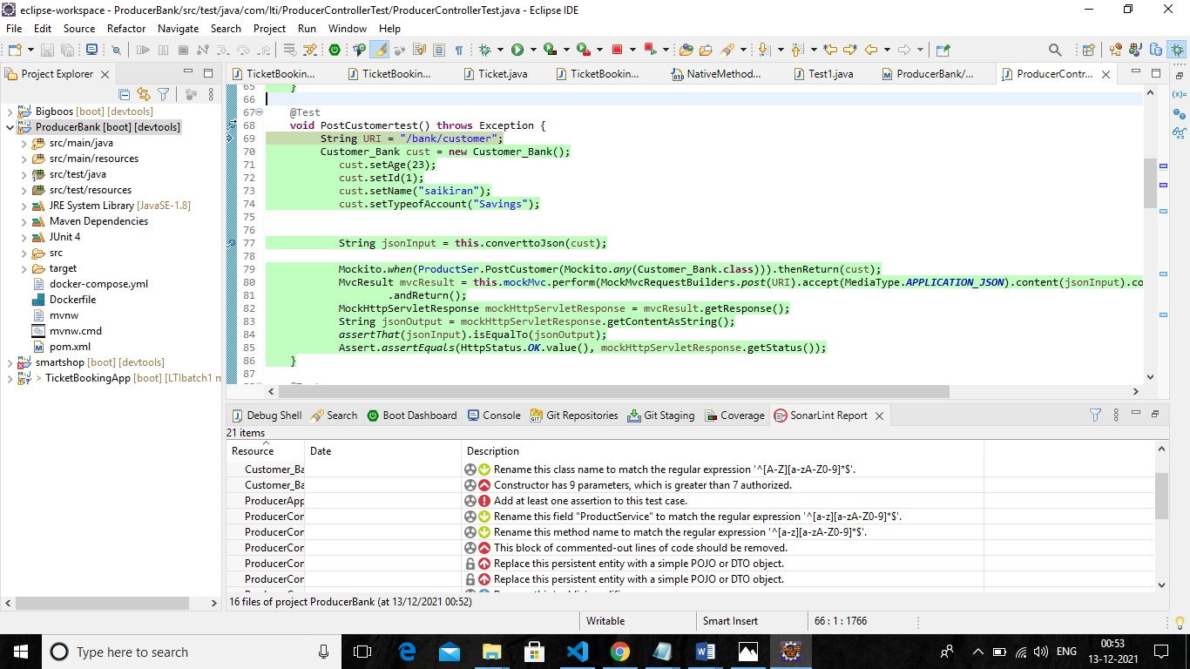

8.SonarQube : 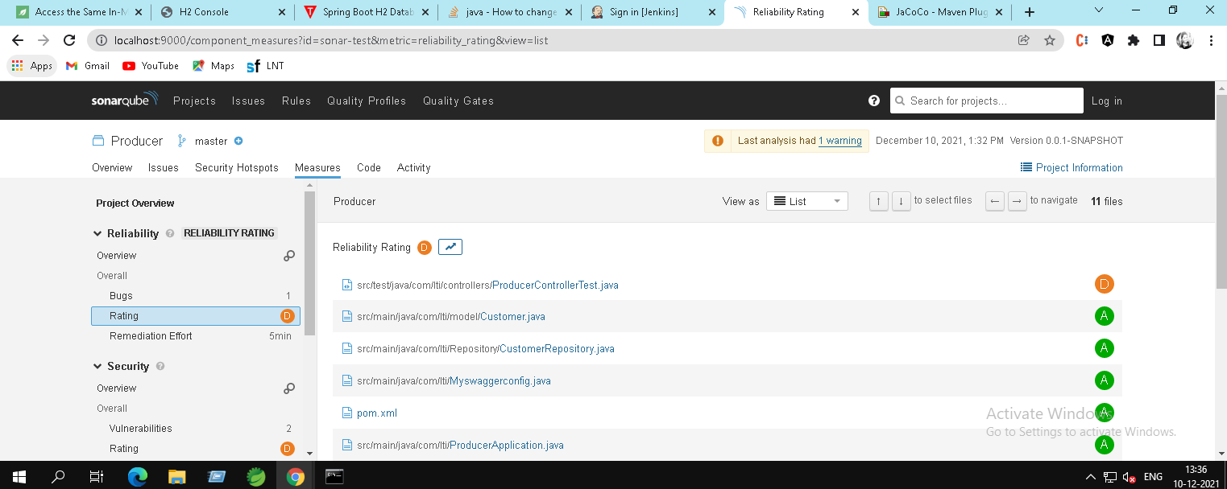

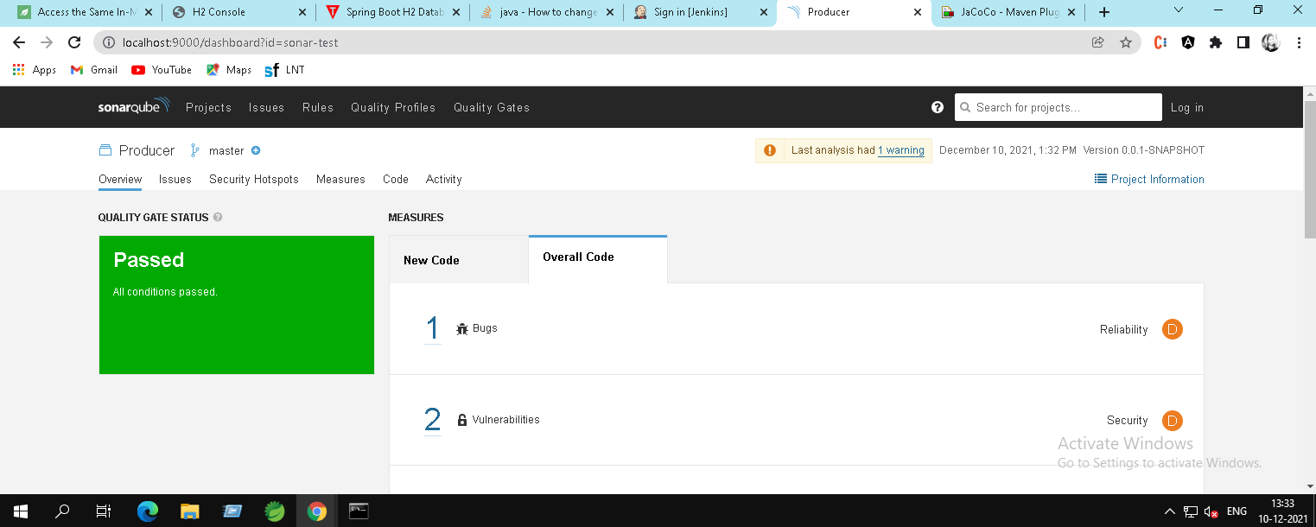

# 9 ) Maven builds

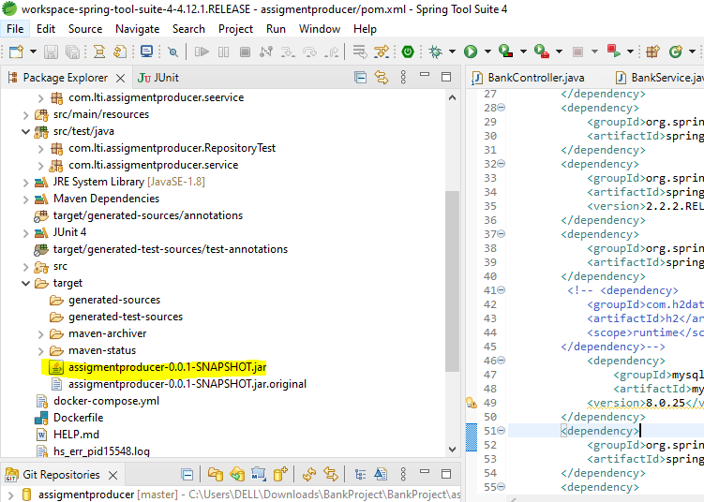

Postman screenshot:

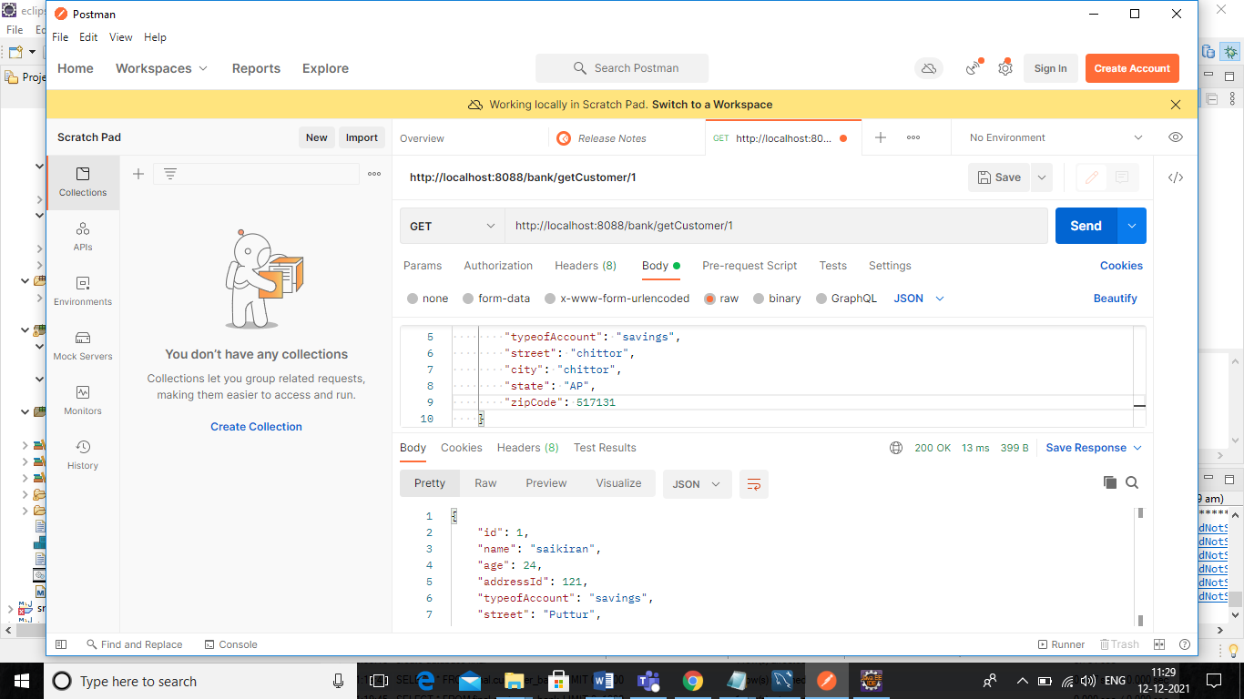

10 ) Docker image and container using docker compose

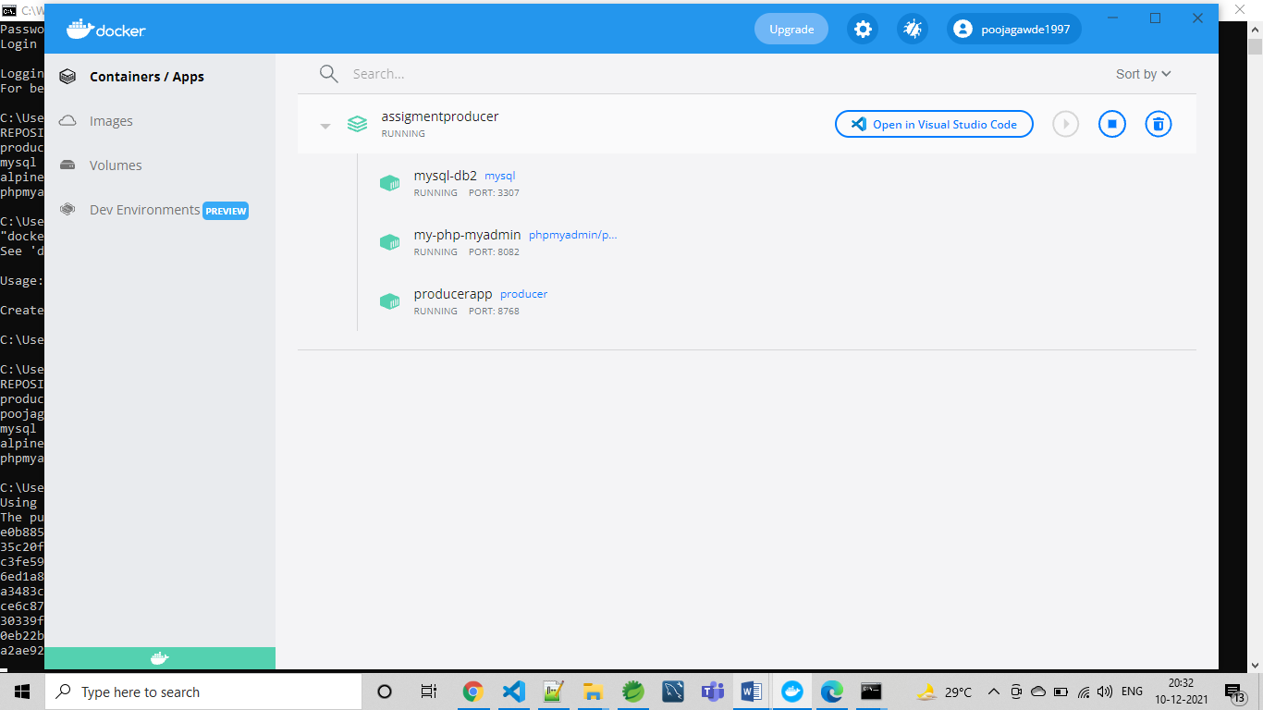

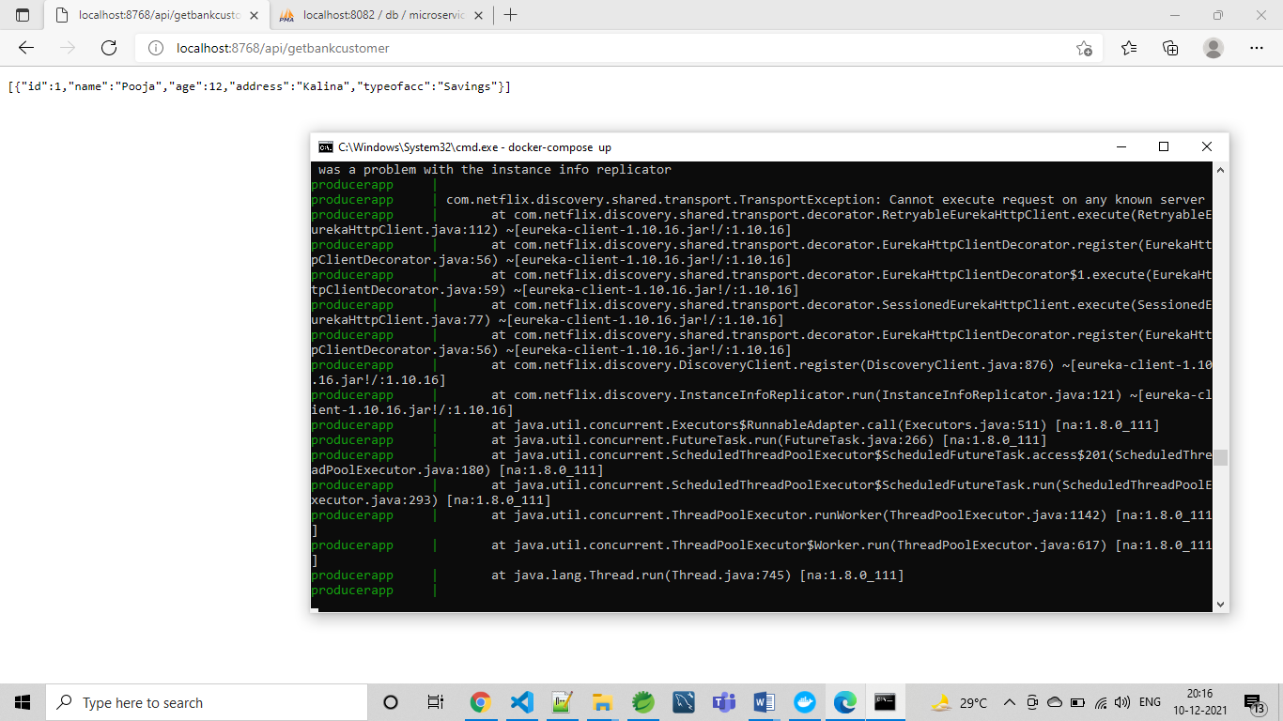

11.Jenkins code pipeline

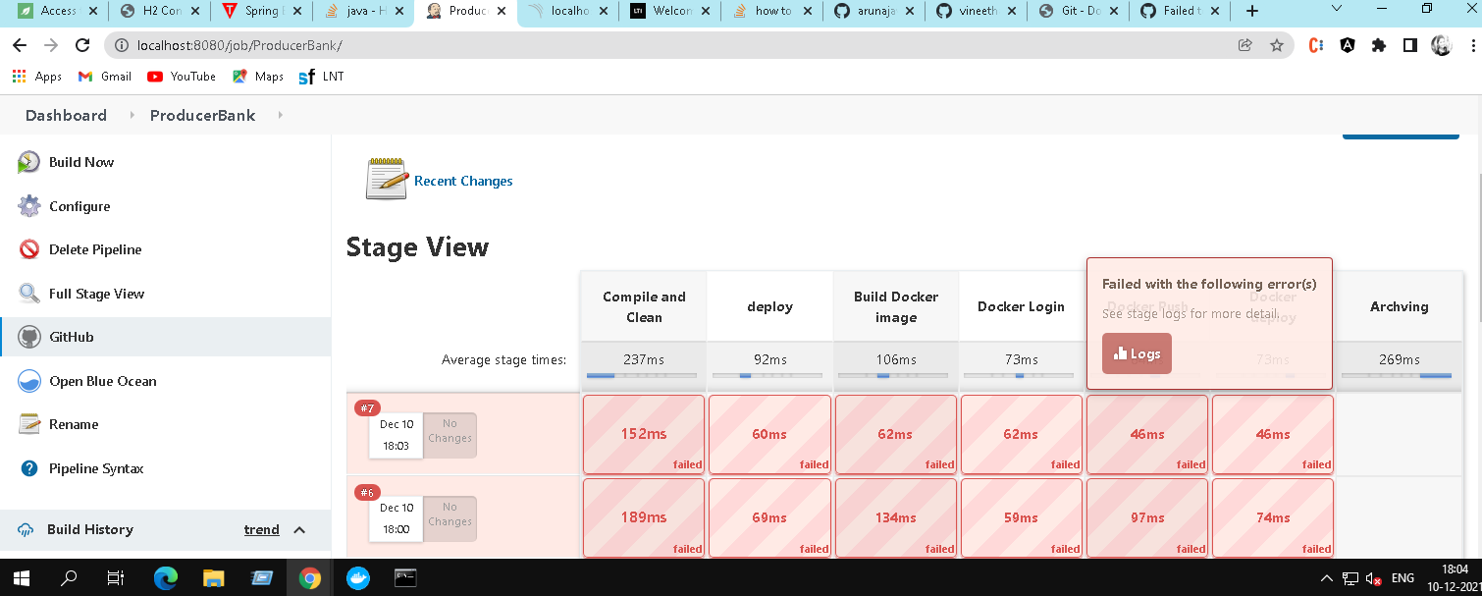

AWS

12 ) S3 to deploy frontend

**Amazon S3 Bucket URL** : https://saikiranltibank.s3.ap-south-1.amazonaws.com/angular/

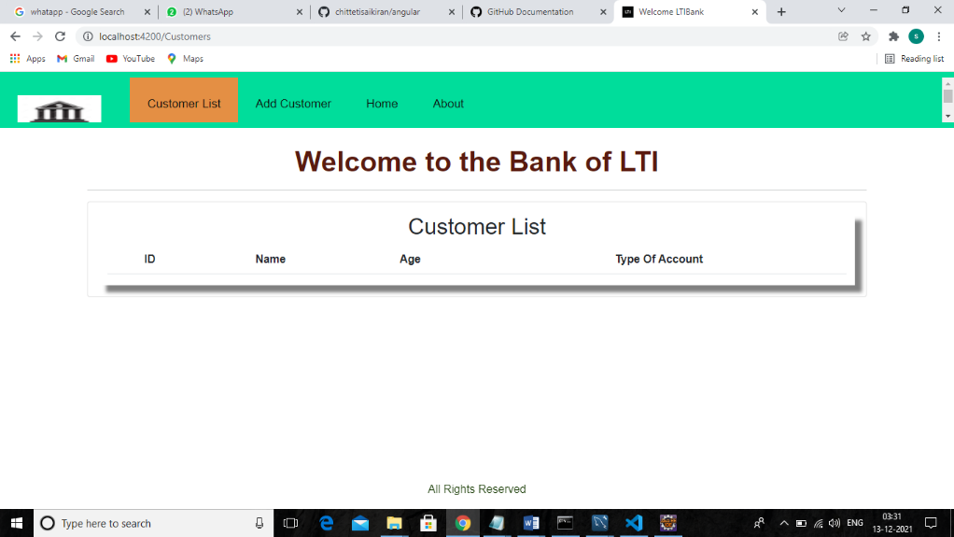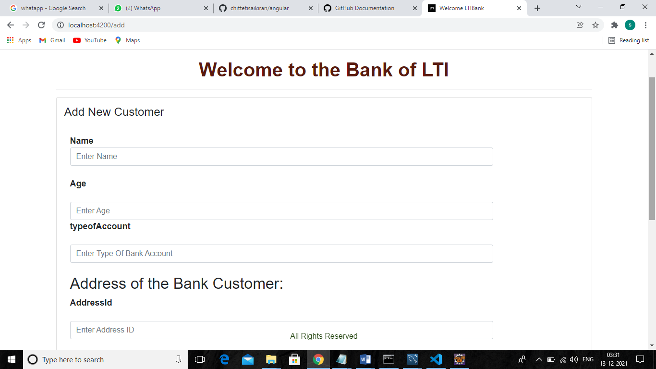

13 ) RDS instance connectivity

RDS URL : jdbc:mysql://database-1.cl8i54z9c899.ap-south-1.rds.amazonaws.com:3307/microservices

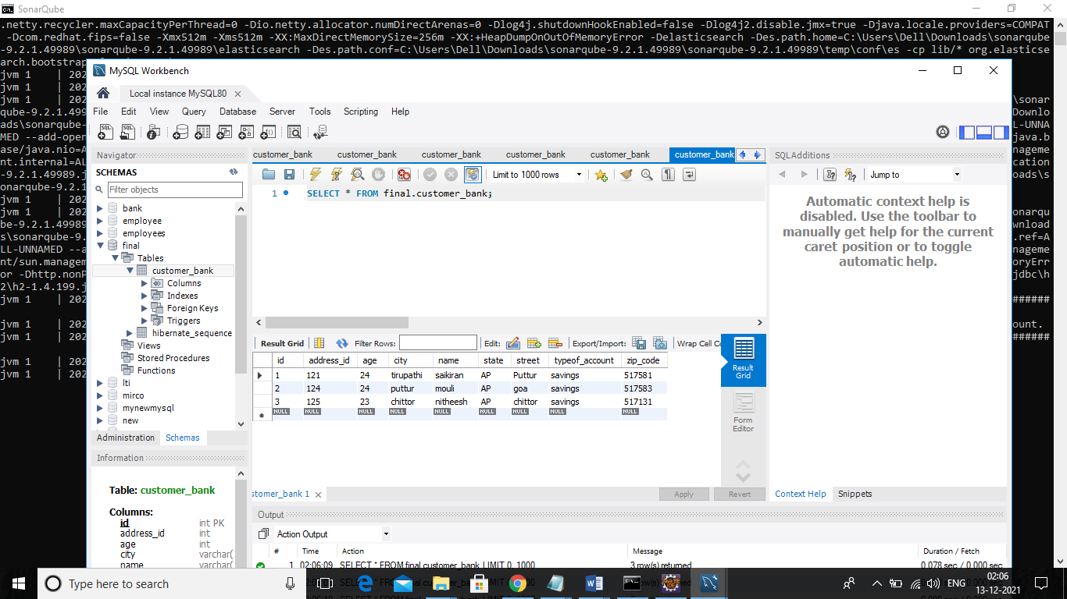

Thank you mam,